*LAB # 02*

*LAB task*

1. *Take your roll number as input.*

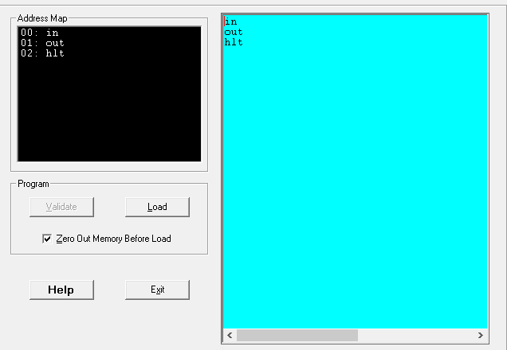

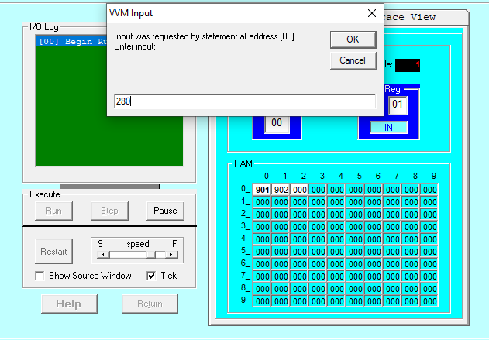

1. *Display the taken input on the screen.*

***Trace View:***

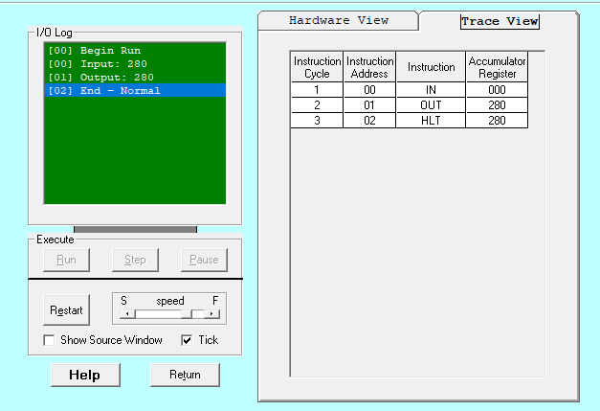

***Hardware View:***

